**SO_SESSION 1**

1. **Some quick notes prior to the lesson**:

* Mua quyển Academic (trái) không phải quyển General Training (phải)

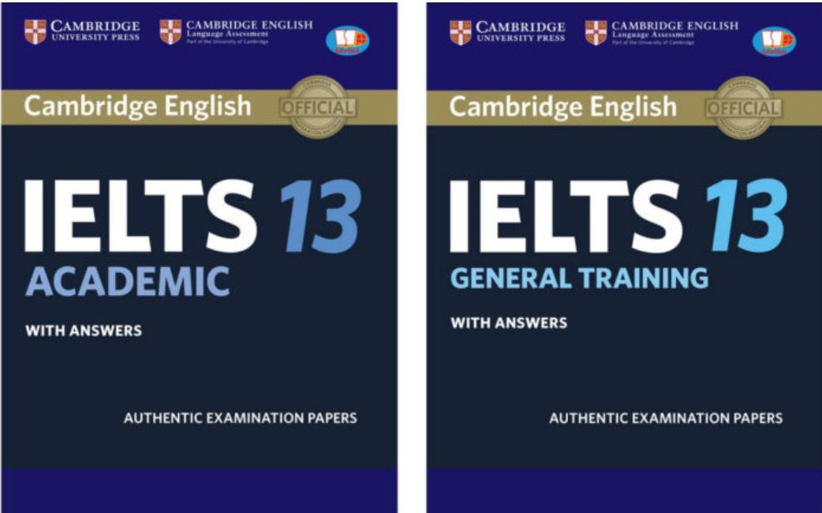

1. **In-class**:
2. Reading:

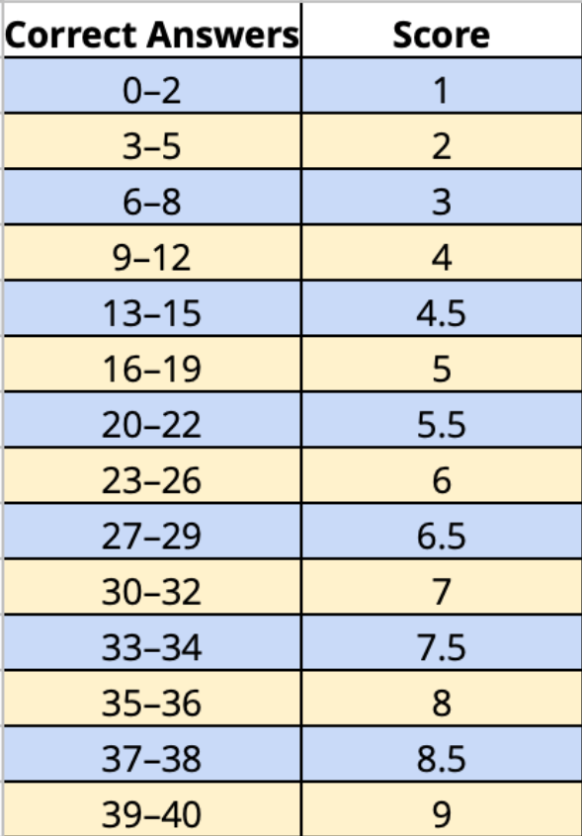

**KEYWORD TABLES:**

|  |  |  |
| --- | --- | --- |
| Questions | Passage (paraphrase) | Language notes  _Paraphrase |
| **[1-8] Sentence completion (hoàn thành câu)_STRATEGY**:  ***having a wide range of vocabulary is the key***  Word limit – giới hạn từ - tối đa bn?  (đọc từng câu hỏi) Underline key words (từ trong bài k thay đổi/thay đổi rất ít)  Scan the reading passage -> locate answers  (get back to the question) Anticipate the form of answers  Read intensively (passage) -> identify answers  The answers follow the order of the reading passage | | |
| 1. The majority of deaths caused by malaria take place in Africa. | The place most intensely affected by malaria is **Africa south** of the Sahara  Desert. About 60% of the world’s malaria cases and 80% of malaria deaths occur **there**. | Take place = |
| 2. Small parasites which live inside Anopheles mosquitoes starts the malaria cyclical process. | The malaria cycle begins with tiny parasites that reside in the bodies of Anopheles mosquitoes. | Small =  Reside in = |
| 3. Timely medical treatment could remedy malaria-infected people. | If medical treatment is started soon enough, sick individuals can be  cured. | Remedy (v) =  Timely (a) = |
| 4. Individuals who reside in rural areas don’t have access to medical treatment. | Unfortunately, many people live in far-away villages without access to quick medical care. | Rural areas = |
| 5. People could use insecticide in wet places and around their houses to get rid of mosquitoes. | One way would be to get rid of the pools of water where they lay their eggs. Also, insecticide1 could be  sprayed in wet areas and around buildings to kill mosquitoes. | Wet areas = |
| 6. Uneducated people may refuse to work with the efforts of the authority. | If they are not educated, the people may be unwilling to cooperate with government efforts to help them. | Uneducated =  Work with = (collaborate with)  Authority |
| 7. Some ministries of health in poor countries cannot afford to construct medical centers or employ professional doctors. | Health ministries do not have the money to build clinics or hire trained medical practitioners. | Afford + N =  Clinics = Professional doctors = |
| 8. A number of aid agencies are now having a priority to assist African countries in preventing malaria. | Helping African nations control malaria is now a top priority of many relief organizations | Country =  Help = assist/support/aid  Aid agencies = |
| **True/False/Not Given**  Passage: Hoàng Anh béo  Question: Hoàng Anh cực béo  (T -> câu hỏi giống 100% trong bài; F& NG: thông tin trong bài khác với câu hỏi, tuy nhiên F khi câu hỏi không thể tồn tại; NG khi có thể tồn tại nhưng không đủ dữ kiện để kết luận câu hỏi)  e.g: (false) Hoàng Anh gầy  e.g 2: … thích chơi thể thao – cực thích chơi thể thao.  **STRATEGY:**  ***having a wide range of vocabulary is the key***  (read the questions) + underline key words  “Scan” -> locate answers  Intensive reading -> decide.  [skim -> đọc và hiểu nd chính]  The answers follow the order of the reading passage | | |
| 9. Worldwide organizations establish that malaria could be controlled with ease. **FALSE**  Đoạn 1 – 2 dòng cuối | international health agencies are finding that controlling it is still an **enormous** and **difficult task**. | With ease = easily |
| 10. The side-effects of quinine to kill parasites have decreased over time. **NOT GIVEN**  Đoạn 4 - 2 dòng cuối trang 1 | Another problem is that the ability of quinine to kill parasites has declined over time | Side + noun: phụ  Sidewalk = pavement  Side dish  Sidekick |
| 11. One of the ways to prevent malaria is using bed nets. **TRUE**  Đoạn 4 - 2 dòng gần cuối trang 2 | Malaria could also be controlled by stopping the mosquitoes.  One way would be to get rid of the pools of water where they lay their eggs. Also, insecticide1 could be sprayed in wet areas and around buildings to kill mosquitoes. Finally, people could be told to sleep under  bed nets to prevent mosquitoes from biting them at night. Bed nets sprayed with insecticide would both stop and kill mosquitoes. |  |
| 12. Old beliefs may conflict with modern ways to cure or prevent illness. **TRUE**  Đoạn gần cuối – dòng 4 | Their old beliefs about illness may conflict with modern attempts to cure or prevent malaria. |  |
| 13. Paying a labor force to spray regularly remains a concern. **TRUE**  Đoạn gần cuối – 2 dòng cuối | They do not have the money to buy insecticide and pay a labor force to spray regularly. |  |

1. Writing: slides